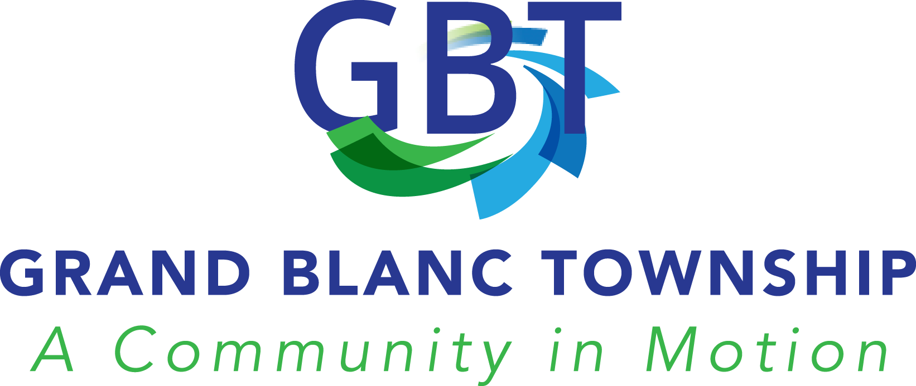

Income and Asset Test Guidelines for Property Tax Relief

Pursuant to Section 211.7u
Michigan Complied Laws

The following income level and asset tests will be used by the Board of Review in helping to determine potential eligibility for a claim of hardship and relief from the payment of property taxes. The property owner pursuing this must file the State of Michigan Application for MCL 211.7u Poverty Exemption (Form 5737) and any other documentation requested by the Board of Review.

General Overview

The Board of Review of the Charter Township of Grand Blanc recognizes the need to have available a procedure by which residents in need of assistance under MCL-211.7u, can make an application for property tax relief. The Board further recognizes that, pursuant to statute, as well as case law, they must adopt procedures and guidelines, approved by the Charter Township of Grand Blanc Board, to be used as standards when considering appeals made based on financial hardship. The Board of Review understands that these guidelines must be adhered to when reviewing hardship appeals, and reserves the right to make individual considerations within their authority, as they feel necessary. Any form submitted that is inaccurate or not fully completed will result in a denial of the appeal. All information in the form is subject to verification from the Board of Review.

Basic Filing Requirements

In order to be considered for exemption under MCL 211.7u each applicant must:

- Own and occupy the property as a homestead, as defined by law, for which the request is being made.

- Complete and submit the State of Michigan Application for MCL 211.7u Poverty Exemption (Form 5737) and Affirmation of Ownership (Form 5739.

- Submit income verification as required. This must include current Federal and State Income Tax Returns, Social Security and pension statements, or any additional information requested by the Board of Review.

Processing Applications

Once the State Application (Form 5737) is completed and returned to the Assessing Department, it will be reviewed by the assessor and prepared for presentation at the next meeting of the Board of Review. The applicant may be asked to attend this meeting in order to answer or clarify any questions in the matter being presented. The Board of Review, in making their decision, may contact the applicant for any additional information they deem necessary. The Board of Review shall also reject an application where the information contained in it appears fraudulent, misleading or incomplete.

An Asset Test is required as part of the application process.
The purpose of an asset test is to determine the resources available (cash and fixed assets and property that could be converted to cash) that could be used to pay property taxes in the year the poverty exemption is filed. The following asset test shall apply to all applications for poverty exemption.

It has been determined by the Township Board that additional assets are limited to a total of $4,000 for individual applicant and/or $6,000 per household if more than one financial contributor.

Please answer the following questions:
1. Do you own a second home or additional land? YES _________ NO_______
2. Do you own recreational vehicles such as campers or boats? YES ______NO______
3. Do you own other buildings other than your residence? YES_______ NO _______
4. Do you have bank accounts with a balance over $4,000? YES _______ NO _______
5. Do you own equipment or other personal property of value? YES _____ NO ______
6. Have you received lump sum inheritances? YES ______ NO ______
7. Have you received one-time insurance payments? YES ______ NO ______
8. Do you own jewelry, antiques or artworks? YES ______ NO ______

Assets greater than the amounts stated above will result in a denial of the poverty exemption. All asset information, as requested in the Application for Poverty Exemption, must be completed in total. The Board of Review may request additional information and verification of assets if they determine it to be necessary and may deny an application if the assets are not properly identified.

Cash and other assets may include but are not limited to:
• Bank accounts
• Stocks and bonds, pensions, IRAs and other investment accounts
• Withdrawals of bank deposits and borrowed money
• Gifts, loans, lump-sum inheritances and one-time insurance payments
• Money received from the sale of property such as stocks, bonds, a house or a car unless a person is in the specific business of selling such property
• Second home, rental property, or building/property other than the residence
• Excess or vacant land
• Extraordinary automobiles
• Jewelry, antiques, or artworks

• Recreational vehicles*
• Equipment or other personal property of value
• Federal non-cash benefits programs such as Medicare, Medicaid, food stamps and school lunches
• Food or housing received in lieu of wages and the value of food and fuel produced and consumed on farms

* Recreational vehicles may include snowmobiles, boats, camping trailers, travel trailers, motor home, jet ski, motorcycles, off road vehicles, or anything which may be considered a recreational vehicle.

Income Guidelines Used in the Determination of Poverty Exemptions for 2021 Local governing bodies are required to adopt guidelines that set income levels for their poverty exemptions and those income levels shall not be set lower by a city or township than the federal poverty guidelines updated annually by the U.S. Department of Health and Human Services. This means, for example, that the income level for a household of 3 persons shall not be set lower than $21,720 which is the amount shown on the following chart for a family of 3.

Below are the federal poverty guidelines updated annually in the federal register by the US Department of Health and Human Services which were adopted in 2020. The Charter Township of Grand Blanc will follow these guidelines for establishing 2021 poverty exemptions:

Size of Family Unit | Poverty Guidelines
1 | $12,880
2 | $17,420
3 | $21,960
4 | $26,500
5 | $31,040
6 | $35,580
7 | $40,120
8 | $44,660
For each additional persons | $4,540

The income guidelines shall include, but are not limited to, the annual income for the person claiming the exemption and all persons living in the principal residence.
Income includes:

• Money, wages, salaries before deductions, and regular contributions from persons not living in the residence

• Net receipts from non-farm and farm self-employment (receipts from a person’s own business, professional enterprise, or partnership, after business expense deductions)
• Regular payments from social security, railroad retirement, unemployment, worker’s compensation, veteran’s payments, public assistance, and supplemental security income (SSI)
• Alimony, child support, military family allotments
• Private and governmental retirement and disability pensions, regular insurance, annuity payments
• College or university scholarships, grants, fellowships, and assistantships
• Dividends, interest, and net income from rentals, royalties, estates, trusts, gambling or lottery winnings.

*Meeting the income levels of the Township policy does NOT guarantee the approval of a poverty exemption. Income and assets are reviewed by the Board of Review in the decision making process.

CHECK LIST
2021 POVERTY EXEMPTION ATTACHMENTS
(Please submit copies only – not originals)
THIS COMPLETED CHECK LIST MUST BE RETURNED
WITH THE POVERTY EXEMPTION APPLICATION

Note: Provide copies of the following as proof for all occupants living in the home even if not contributing to household income or expenses.

____ Timely filed and fully complete and signed Poverty Exemption Application.
____ Copies of 2021 Federal and State Income Tax Returns (or completed Form 4988, Poverty Exemption Affidavit, if you are not required to file income tax returns).
____ Copies of 2021 W-2 Forms, Social Security Statements (SSA-1099), Disability Statement or similar income verification for all household members
____ Copies of statements from additional income sources including unemployment, alimony, child support, ADC, Food Stamps, etc.
____ Copies of statements for checking account, savings account, certificate of deposit (CD’s), stocks, bonds, pension (IRA, 401, etc.) account or any other asset/retirement account
____ Copy of 2021 mortgage/equity loan payment verification showing the current loan balance and principal and interest payment amounts.

