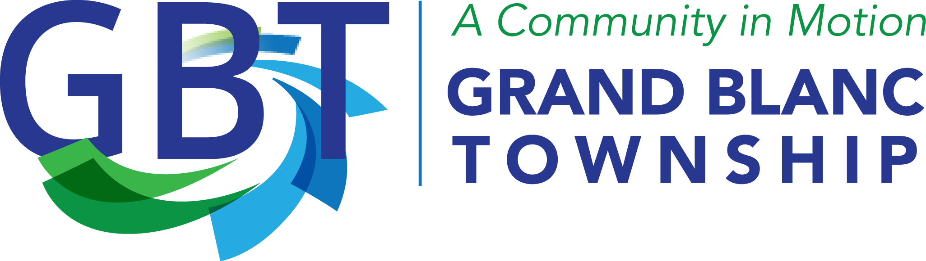

STRATEGIC PLAN
2025-2028

OVERVIEW
On Saturday, April 5, the Supervisor, Clerk, Treasurer, and Trustees of the Grand Blanc Charter Township Board were joined by the Superintendent and Senior Staff to discuss accomplishments since the 2021 strategic plan, challenges facing the township, and the vision and goals for moving the township forward over the next four years. The following reflects the results of their discussion.
BOARD VISION TOUR
In 2028, a visitor to Grand Blanc Charter Township could be given a tour and see the following:
- An Amphitheater in Bi-Centennial Park
- Paved roads at the park
- Progress at the Henry Ford Campas
  - VA Center, Hotel, Assisted living facility
- Tech village
- Senior Center improvements
- Sanitary sewer in the park
- Community engagement
- Businesses with high-paying jobs
- The park will include indoor recreation for basketball, etc. For example, the current Township campus might one day serve as a community center
- Advance Planning for future traffic
- Road from the back of EMS to McCandlish, more connectivity of roads
- Sidewalks on Saginaw north of Hill Road
- More flexible zoning in the Pointe North (condo/duplex)
- Looking more closely at zoning (Minimum lot size?)
- Park goals – splash pad, paved parking lot, sides on the pavilions, basketball, pickleball courts, satellite park
- Develop campus here for recreation
- Community center (repurpose school or church))
- Improvement in mobile home parks
- Retention of youth in the community
- Park and recreation activities for all ages
- Celebrate diversity with community activities
- 911-EMS response time
- Allocation of police and fire services

2025 SWOT ANALYSIS
Strengths
- Economic development/growth
- Services to community
- Highest taxable value in Genesee County
- County community leaders/resources
- Staff (customer satisfaction)
- Public perception/Survey results
- Location
- Communication/teamwork
- IT
- Unfunded liabilities
- Infrastructure
- Robust ordinances
- Bicentennial Park
- Board leadership (vision)
- DDA
- Facilities (New fire/DPW buildings, newer police building-attractive to recruits)
- Public education (communications)
- Public safety
- Employee benefits
- Longevity
- Mix of employees (new & long term) skills & experience

Weaknesses
- Increased health care costs
- Moving from paper to digital
- Reliable seasonal workforce
- Negative culture lingering
- Lack of community entertainment
- Lack of restaurants
- Going to lose data at PD eventually if we don't migrate data when we move platforms
- Newer workforce-losing institutional knowledge
- Transportation options (Pathways/Ride share)
- Communication w/all age groups in community
- Downtown area lacking
- Communication concerns when we expand our buildings staff adjustment to help with growth changes/new buildings
- Collective bargaining Challenge

Opportunities
- Board Stability
- Infrastructure growth (Tech Village)
- Family opportunities
- Staffing growth/Knowledge & education
- Enhance communication within buildings (Internal & external)
- Community engagement
- Enhance communication with public (education & public forum)
- Use technology to full potential
- Parks/Trails/ Events
- Strategic Plan Process
- Change neutral to satisfied on community survey through communication
- Enhancing cybersecurity
- Community job growth
- Community housing growth (Megasite)
- Increasing communication & connection with GBT employees
- Business Connection

Threats
- Cyber security (AI, phishing, vulnerabilities, federal funding)
- Outgrowing space (GBT offices)
- External funding changes (state & federal)
- Recruitment/Retention
- Misinformation-internal/external
- Election outcomes
- Economy
- Aging utilities
- Competing neighboring communities (investment-developments- business
- Genesee County services we must rely on

GOAL AREA: COMMUNITY ENGAGEMENT

KEY OBJECTIVES and STRATEGIES:
- County 911 and EMS response
  - Review of legal opinions provided in 2022 (May 27, 2025, Agenda)
  - Discuss role of Township PD and FD, i.e. lift assists, MFR, EMS in the future
  - Explore all service delivery methods to maximize service to residents

- Citizens Academy
  - Fall of 2025 timeframe
  - 6-10 weeks with a different department presenting at each weekly session, for example; week one is a broad overview of the structure of local government presented by Elected Officials and Superintendent, week two is a review of the functions of the Clerks Department, week three is a presentation by Township Treasurer and Finance Departments, week four is presented by the DPW Department, etc.

- Engage the County Board of Commissioners in allocation of County millage funds and operations of various supported departments
  - Form Board member committees to champion specific areas of concern and develop the plan of action for addressing challenges (by July 2025)
    - Board committee members engage at County meetings (Who, when, etc.)
    - Develop alliance with neighboring Township Board members
  - Support business development activities throughout the County by working with Dr Brown on the economic development initiative (Supervisor Bennett participating on June 5, 2025)

- Enhanced Community Engagement Efforts through Outreach
  - Parks & Recreation focus on events and programs that do not compete with other organizations, i.e., GB Schools running basketball programs
    - Central solution for securing sponsorships for community events
    - Youth Advisory Councils for civic engagement
    - The Grand Initiative (details to follow)
    - P&R will provide a presentation on potential enhancements in June 2025
  - Enhancing communication efforts to reach more residents
  - Develop and support activities that include diverse segments of the community (International food event at Bicentennial Park)

GOAL AREA: INFRASTRUCTURE - Prepare for growth

KEY OBJECTIVES and STRATEGIES:
- Sanitary Sewer and Paved Roads through Bicentennial Park (2025 Planning)
  - Review options and routes for cost effective project (Rowe Engineering) 2025 (Project dependent on millage approval)
  - Include long term vision on growth to ensure route does not impact future development, i.e., amphitheater or sports fields

- 9-1-1 EMS response time and service to GBT residents
  - Board discussion to explore and understand the issue and potential solutions (2025 ongoing)
  - Review of legal opinions regarding current dispatch methods (May 27th Meeting)
  - Determine financial viability of moving from Genesee County 9-1-1
    - Discuss working with City of Fenton on PSAP
    - Board to study and hear a presentation on GBT Fire Department moving to a response model to include medical response, costs and timeframe vs. private EMS company

- Planning for the Future
  - Joint Board and Planning Commission meetings (Q3 2025)
    - Master Plan ready for long range growth?
    - Zoning – flexibility for lot size approved uses
    - Mobile Home Parks
  - Township meetings with Genesee County Road Commission Staff
    - Long range traffic study based on anticipated growth patterns for commercial and residential growth
  - Sidewalk funding and location for the North End Corridor

- Long Range Vision for the Township Campus Plan (2025 + ongoing)
  - Study location of a new Township General Office
  - Study reuse of current Main Office building
  - Public Access to walking trails looping the property
  - Possible Community Center

GOAL AREA: COMMUNITY DEVELOPMENT

KEY OBJECTIVES and STRATEGIES:

- Technology Village Development
  - Review current progress and develop timeline based on developer commitment (July 2025)
  - Review of the DDA/TIF Plan
    - Joint meeting with the DDA and Board (August/Sept. 2025)

- Support a range of housing developments
  - Review Master Plan and current and future land use maps
  - Discuss during the joint Planning Commission – Board meetings

- Engage the Henry Ford Genesys Health Park on development
  - Establish working relationship with new hospital personnel for the purpose of examining future planning for campus development
  - Introduce the Henry Ford personnel to the DDA Plan to provide examples of potential assistance for development

GOAL AREA: ENHANCED PARKS AND RECREATION, COMMUNITY CENTER

KEY OBJECTIVES and STRATEGIES:
- Explore opportunities for indoor recreation activities
  - Asset mapping for indoor spaces both within and outside the GBT boundary
  - GB Schools facilities are getting hard to access, find ways to improve

- Enhanced Youth and Senior Programs
  - GRAND Initiative

- Establish neighborhood pocket parks
  - National Park standards for access from home within 10-minute walk
    - Adopt landbank parcels
  - Opportunities at Township Campus (Dort parcel)

- Senior Center Improvements
  - Work with Grand Blanc City partners on vision for future
  - Establish a political action group of Board and City Commission members to fight for funding at the County Board level

- Perry Homestead and Nature Trails
  - Museum partnered with Historic Society
  - Long Range Visioning session

Next Steps
- July 2025, Board adopts the final 2025-2028 Strategic Plan
- The Board will form committees as needed to assist in various initiatives , including engaging the County Board of Commissioners to champion economic development and allocation of resources throughout the County
- Board agenda to include monthly updates on the progress of the Strategic Plan
- Board will review in January 2026 with revision of goals as necessary
- Immediate review required for any impacts from unexpected internal or external environment changes, i.e., loss of revenue, natural disaster, etc.

Grand Blanc Townships Mission Statement:

“Delivering premier services to Grand Blanc Township through excellent customer service and continuous improvement, while encouraging growth.”

